**Comparison of Prices Fruits and Bakery products in a shop.**

1.Data Acquisitions:

2.Data Pre-processing

3.Statistical Analysis

4.Plotting Data

5.Interpretting Graphs

6.Conclusion

The data was taken from Faisal Market, Sadiqabad Road, on 4 November 2022. The purpose for collecting this data was to compare the prices of two random product categories including fruits and bakery products. We randomly selected four items including apples, oranges, bananas, and lemons from fruits category and five items including Donuts, Cookies, Cakes, and Pies from bakery products and proceeded with data analysis. We analyzed the data for comparison using two tailed, unpaired student’s t-test at 95% confidence interval.

**Results:**

Two food (Fruits, Bakery products) items were compared using Microsoft Office Excel 365 (Reference), No, significant difference (p=0.565) was observed between the prices of fruits and bakery products according to the student’s t-test p<0.05. as shown in figure in report

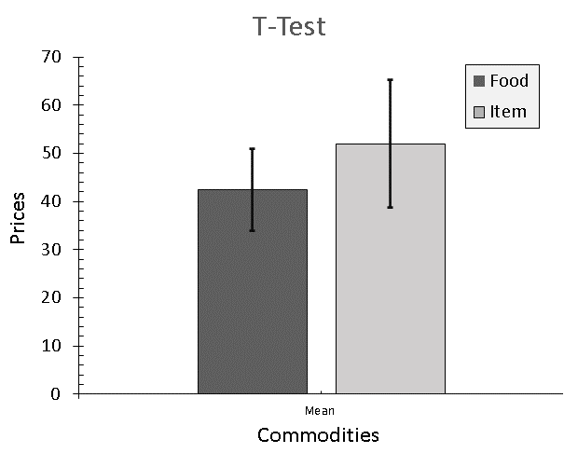

**Figure 1**. *The bar graph showing the prices of fruits and bakery products. The error bars show the ±SE of 4 and 5 replicates, replicates, respectively.*

**Conclusion or Recommendation:**

As there was no significant difference observed, please re-sample the commodities or try to use another sampling technique where you take more than five samples for each fruit separately and then pool the prices together. Change your perception about the comparison methodology.

**Name:** Moiz Ali

**Status**: Data Scientist

**Email:** [moizali1122125@gmail.com](mailto:moizali1122125@gmail.com)